 Methods Unit 3 Test 3, 2018

(Calculator Free) Name__________________

Time: 20 minutes Marks: 20

Show working in sufficient detail to support your answers. Incorrect answers given without supporting reasoning may not be allocated any marks.

1. [2, 2, 2 marks]

Determine $\frac{dy}{dx}$ in terms of x, for the following (you do not need to simplify):

a) y = e2-3x . cos (2x -1)

b) y = $\frac{sin⁡(x)-cos⁡(x)}{4cos⁡(x)}$

c) y = sin(4x) – cos2(1 – 4x)

1. [2, 2 marks]

Determine the following indefinite integrals:

a) $\int{{3cos}^{2}\left(2x\right)\sin\left(2x\right) dx}$

b) $\int{\sin\left(2x\right)Cos\left(3x\right)+Sin\left(3x\right)Cos\left(2x\right) dx}$

[4 marks]

Evaluate

4. [4, 2 marks]

Consider the Discrete Random Variable X defined by the table below.

|  |  |  |  |  |  |
| --- | --- | --- | --- | --- | --- |
| x | 1 | 2 | 3 | 4 | 5 |
| P(X = x) | a | 0.15 | b | 0.15 | 0.2 |

a) Given E[X] = 2.8, determine a and b.

b) Determine P(X < 4|X $≥$ 2)



Methods Unit 3 Test 3, 2018

(Calculator Assumed) Name___________________

Time: 40 minutes Marks: 40

Show working in sufficient detail to support your answers. Incorrect answers given without supporting reasoning may not be allocated any marks.

5. [5 marks]

Given that 0< x < $π$, determine the exact coordinates of the point(s) on the curve y = 2 sin (x – 1) where the gradient is 1.

6. [6 marks]

The probability distribution for a discrete random variable is

f(x) = $\left[\begin{matrix}\frac{2-x}{k+1} for x=0, 1 \\ 0 for all other values of x\end{matrix}\right.$

Determine k, and hence determine E[X] and StDev[X].

1. [2, 1, 2, 3, 3 marks]

An avocado grower regularly sells fruit to supermarkets, and each avocado is checked for size before transporting. It is found that 1 in every 8 avocados is rejected as too small.

A box of 50 avocados is ready to be checked.

What is the probability that

a) at least five avocados will be rejected?

b) one avocado will be rejected?

c) no more than five avocados are rejected, given at least one is rejected?

d) The probability that a box of avocados are all correct size (no rejects) is approximately 0.07. How many avocados in the box?

e) The grower selects five avocados.

i) What is the probability that exactly one is too small?

ii) What is the probability that at least one is too small?

8. [3, 4 marks]

A game is played at a football club fundraising event. Each player pays $2 per game.

Two dice are rolled and the uppermost faces are added. If the result is a total of 2 or 12, the player receives $10. If the result is a total of 7, the player receives $5. Otherwise, no prize is awarded.

a) Determine how much the club would expect to raise after playing 100 games.

b) What is the maximum amount that could be paid for “2 or 12” (instead of $10) and not make a loss on the game?

9. [4 marks]

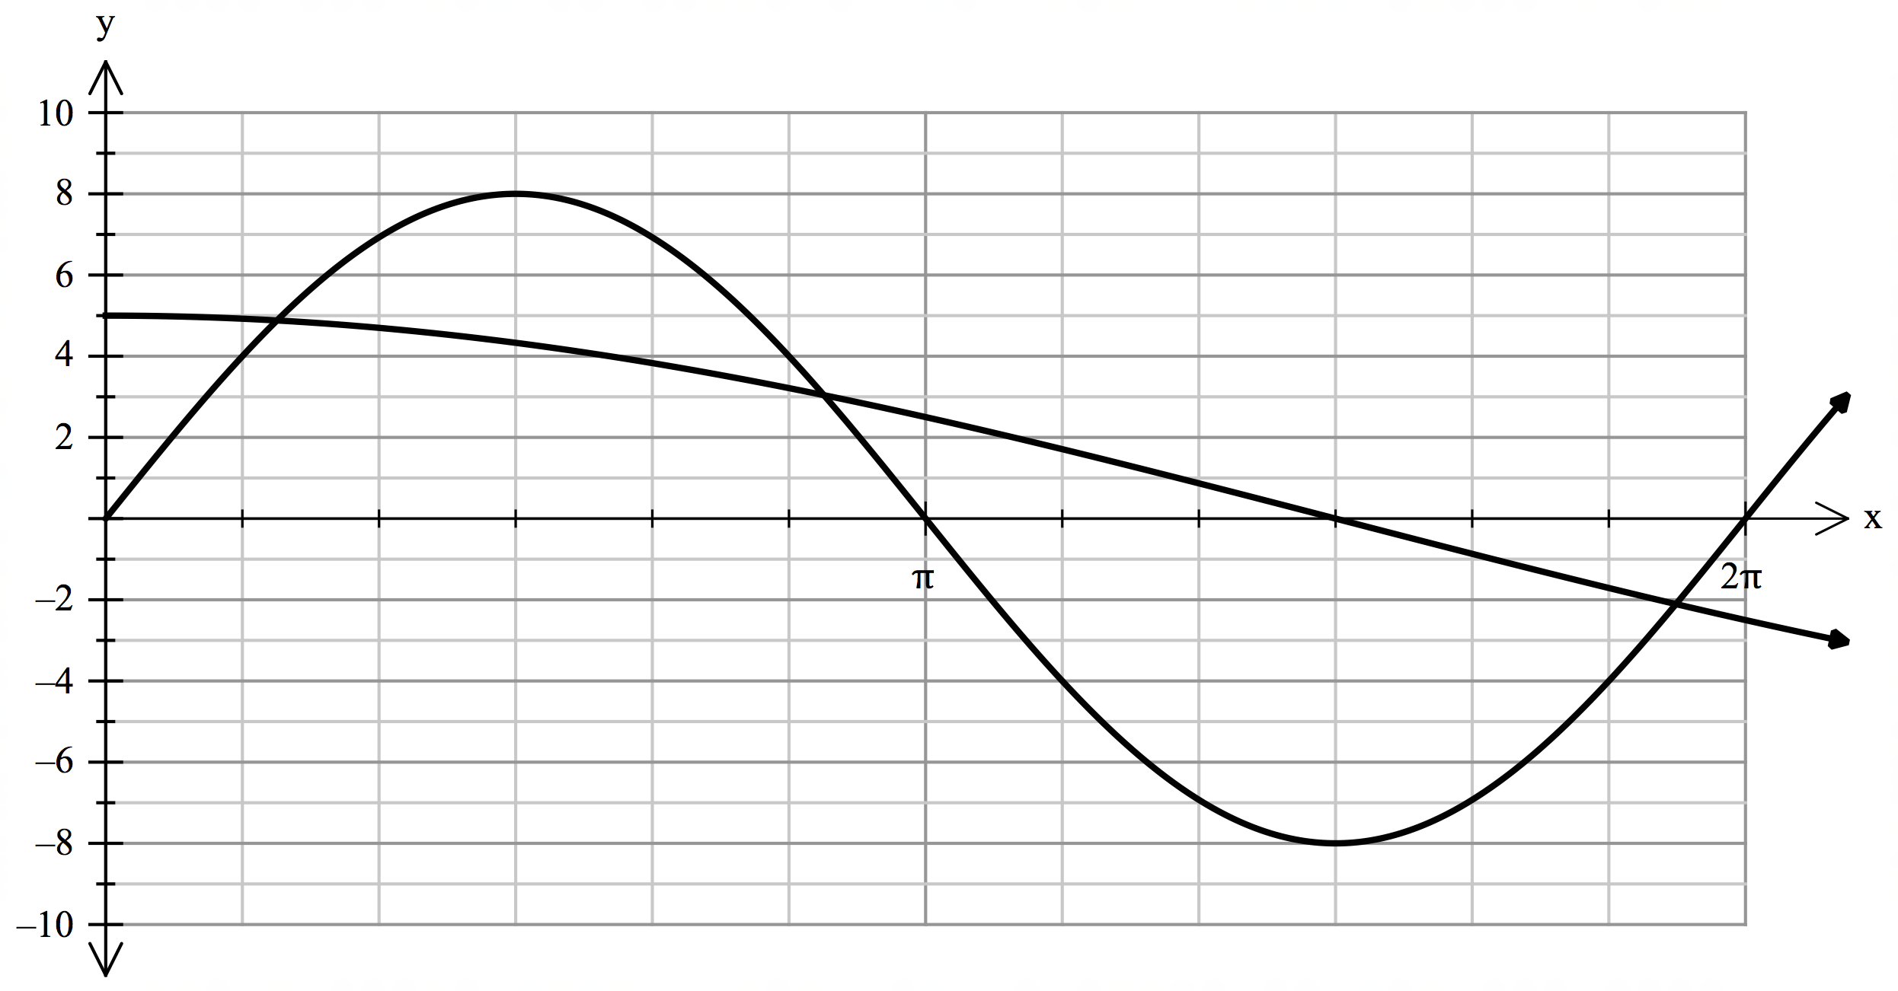

Determine, using calculus techniques, the approximate area between y = 8 sin(x) and y = 5 cos( $\frac{x}{3}$), as illustrated above. Round your answer to 1 decimal place.

10. [1, 2, 2, 2 marks]

For a particular binomial distribution where X $\sim$ bin(20, *p*), the mean is 7.

a) Determine *p.*

b) Determine the standard deviation.

c) Determine E [5 – 2X]

d) Determine Var [5 - 2X]